### Data Flow Diagram

(5 points) Create a context diagram and (5 points) level 1 diagram showing the flow of information and processes of the system.

### <https://docs.google.com/presentation/d/1-j_KyXMenoYkhNSKMCqEU1l5e7eO_a21xYJkRiBGq18/edit?usp=sharing>

### Models and Associations

(2 points) Define the models you will need in your application. Be sure to include all model attributes and model attribute data types.

The models we will be using in this application are:

* **User Models**
  + **Model Attributes:** username, password
  + **Model Attribute Data Types:** Character & Numeric Data,
* **Event Models**
  + **Model Attributes:** begin_time/date, location_of_event, event_description, length_of_event, image_placeholder
  + **Model Attribute Data Types:** Character & Numeric Data, Date/Time Data, BLOB data (in case a user wants to add an image for the event)

(1 Point) Decide which associations between the models are appropriate using the Basic Relationship Pattern (Links to an external site.) Page.

**For the associations between the User & Event models we will be using the many to many association type given that our final application will support various users and provide them with a large variety of events.**

Add these associations to your document.

### Update Lo-Fi UI prototypes

Label each of your Lo-Fi UI prototypes with the below information and paste them into the document. Again, Google slides will allow you to easily label images.

1 - (2 points) function name for any UIs that will correspond to a route.

2 - (2 points) View name -- e.g., index.html

3 - (2 points) Database field names for all input fields. These would represent the properties/fields/attributes of your models.

4 - (2 points) route action (method) for any buttons or links that correspond with actions in the app. i.e. A "show" link may correspond with the show method in a particular route. Remember your CRUD actions!

Paste screenshots of each of your labelled UIs into this section of your project document.

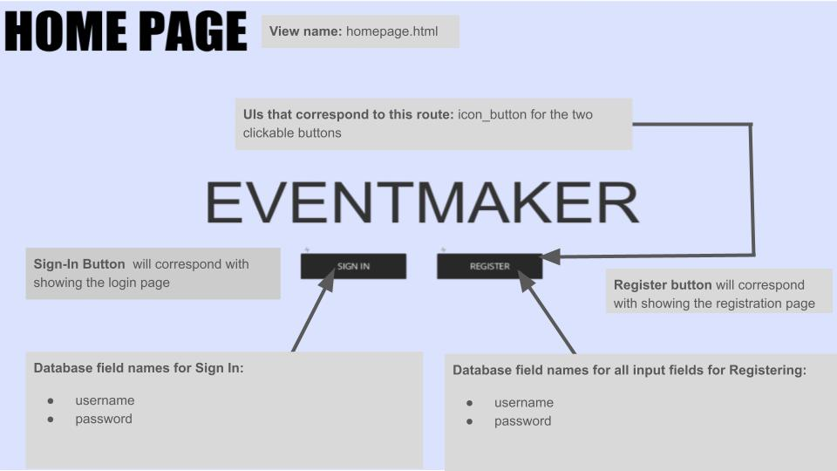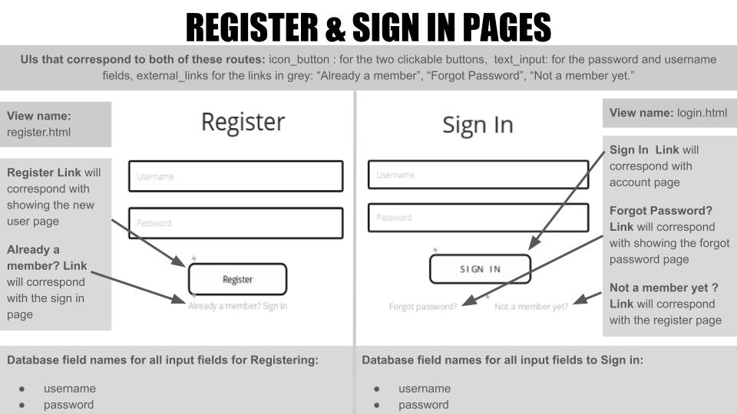

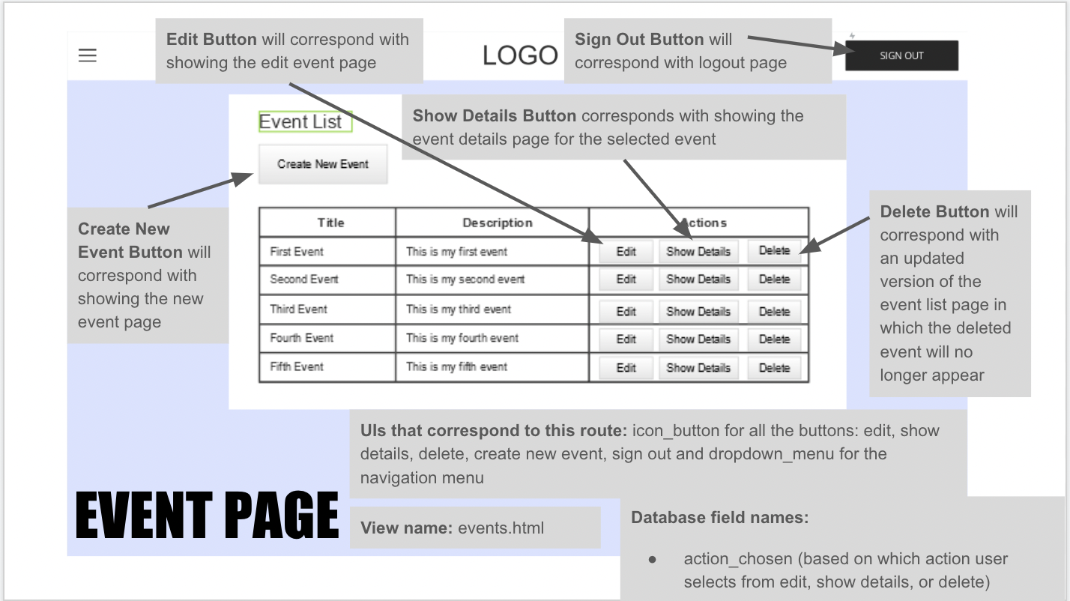

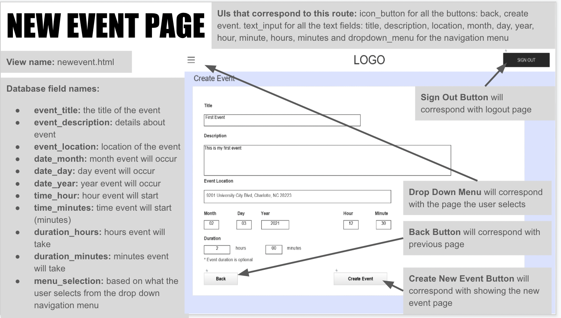

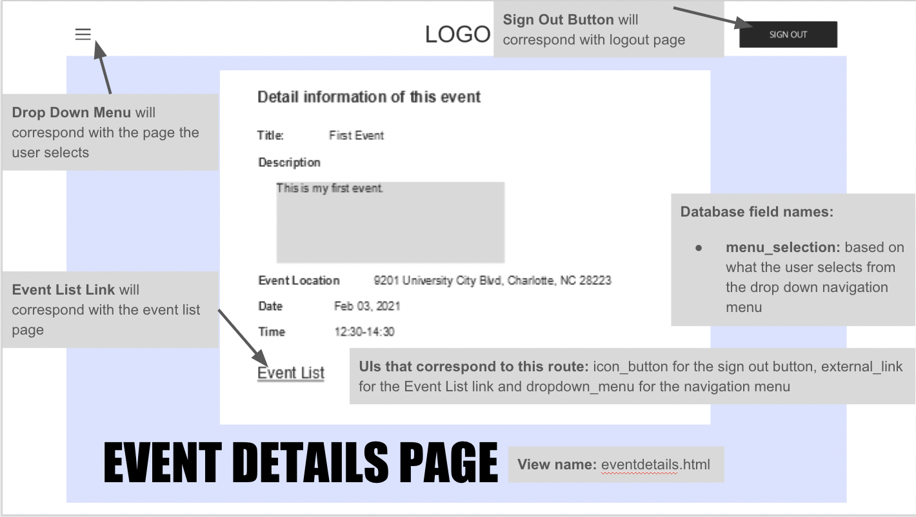

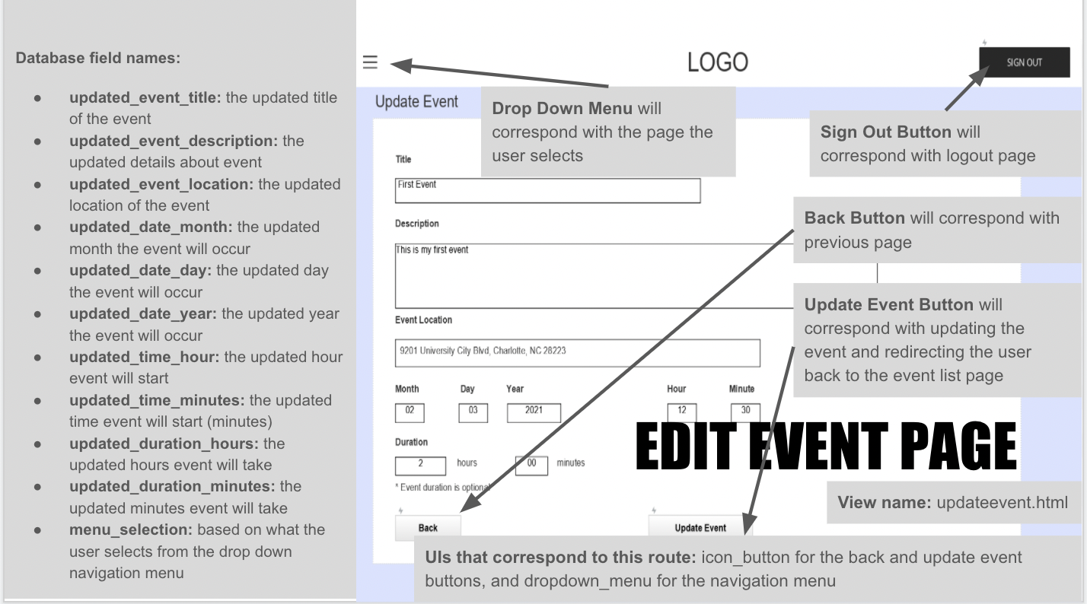

### Update Backlog

(1 point) Update your product backlog to reflect the current status of your project and include a screenshot in your project document.

As of 4/4/2021

